D’Nylah Beaty
English 1201
Professor Graue
22 March 2019
A Change in the Tobacco Industry
According to the Center for Disease Control and Prevention, “Cigarettes are the leading cause of preventable death in America… cigarette smoking is responsible for 1 in 5 deaths” (CITE) The use of tobacco is very popular among citizens in America, many people are getting life threating diseases or in some cases even dying. Tobacco big problem not only for the smoker but the people around them. Tobacco cause many health issues that could be prevented some issues are cancer, flare up of asthma, short breath, rotting teeth, skin peeling, and blood circulation that is a short list of some of the results. Tobacco has no health benefits for the human body, it helps to deuterate the body. In Indonesia, there are little to none restrictions on smoking. Many children smoke and smoking is marketed to children. In Australia, there are strict guidelines on tobacco usage the government controls the display of packaging, prices and much more. There should be more strict guidelines on tobacco usage around the world for the benefit of human health.
Tobacco originates from the plant nicotiana. The leaf is cured through a process of drying and fermentation, later it is smoked or chewed by consumers. Tobacco originates in the America’s, dating back as far as the 17th century; however, this is claimed to be one of the plants Christopher Columbus brought back to Europe when he first sailed to America. There are five major retailers of tobacco: China tobacco, Phillip Morris International, Imperial Brands, Japan Tobacco International, and British American International. The average smoker in America smokes between ten cigarettes to a pack a day. Washington D.C has the most tobacco smokers in the U.S Utah hold the lowest number of smokers. Tobacco contains a very addicting ingredient, called nicotine that causes a rush of Adeline. Tobacco comes in many forms: cigarettes, cigars, dissolvable products, waterpipes, e-cigarettes, and chewing tobacco.
America does not have strict guidelines about smoking. The advertisements for smoking were banned in the 1960’s. The Federal Communications made a document called the fairness Doctrine this began to shift the positive view on the use of tobacco. This doctrine allowed people to see the side effects of smoking with anti-smoking ads, in 1967. To prevent the outreach to younger children and appeal to an audience that had just got out of war. Back then many people had come home from war and used tobacco and alcohol to suppress their emotions. In 1972, allow tobacco advertising was banned completely. In 1973, the smoking sections in airlines were unassembled on commercial airlines. In 1975, cigarettes were banned from k-rations. K- rations are packs of food that were passed out to military troops. In 1987, smoke free environments were implemented into human and health services. In 1992, the federal trade commission begin to enforce the teaching of smokeless tobacco health. Smokeless Tobaccos Health Education Act allowed smokers to know some of the many side effects cigarettes cause. This made smoker now more aware of what they were doing to their bodies when they put the foreign chemicals in their body. This Act also prevents smokeless tobacco ads from being produced. In 1993, the environmental protection agency begins to access the effects of smoking on the environment and release the data that was found. Cigarette smoking cause pollution not only in the air but in the water and soil. In 1994 to 1996, president Clintons bans the cell of tobacco to minors. He begins to provide programs to teach children that smoking doe nothing positive for human health. In the 2000’s, there have been rules placed where your insurance can be raised because you are more at risk for health issues if you are a smoker.
This Photo by Unknown Author is licensed under CC BY-SA
Above is a picture of the plant tobacco
In Indonesian, there are little to no guidelines for smoking. Smoking is widely promoted. 92.5% of the tobacco industry is owned by Phillip Morris, who was mentioned earlier as a part of the big five. They use cartoons, baby clothing and other advertisements to appeal to young children. Many children smoke in Indonesia starting at the age of two. 76% of males 15 and up smoke this is the highest percentage in the entire world, around 250,000 Indonesians die from a preventable disease caused by smoking. By the age of 13 90% of children have at least tried smoking if they are not already addicted. Indonesia is one of the last countries around the world that allow direct advertising of tobacco. They have put restrictions on their advertisements, the tobacco advertisements can only be played from 9:30pm to 5 am; however, the tobacco industry still finds a way to make it appeal or be shown to adolescents. Even though the tobacco industry denies this to be true. Indonesia has the highest rate of smokers across the world.
Below is a graph of the tobacco consumption in various countries around the world, and it is very evident Indonesia is in the lead for most smokers.
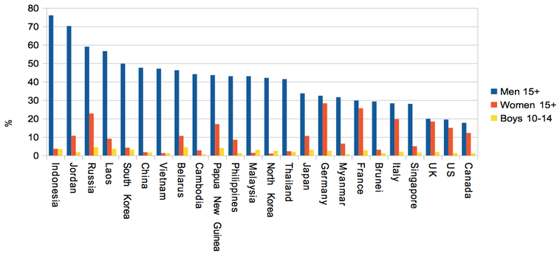
Below is a picture of an Indonesian child smoking a cigarette. The picture received much criticism in many other places around the world.
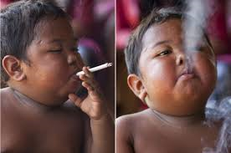
Smoking is claimed to heal the body in Indonesia. They use smoking to heal many body issues like headaches, ears infections, body aches, and much more.

In 2011, Australia made a Tobacco Plan Packaging Enforcement Policy. This policy was used to help people use their better judgment for health reasons. This was also put in place so that smokers do not have to investigate other sources to see the effects smoking has on their health. This plan was not introduced in 2011, it was introduced in April of 2010. But the plan was not enforced and was looked over but many consumers and sellers. The Tobacco Plain Packaging Act came into full effect in December 2012. This gave all the distributors plenty of time to change the packaging and get rid of all their old supplies. All tobacco packaged or sold Australia must have plain packaging. The price of cigarettes rose as well with a higher tax, the average 25 pack of cigarettes are $28.25 to $33.90. The packaging helps eliminate the liability of smoking companies because it is clearly placed on the packing the possible side effects from using the tobacco products. Imports of tobacco are not allowed because they do not follow the Act that is strongly enforced. If manufactories do not comply with the orders given by the legislation, they are first given a written warning letter, then infringement notices, court enforcement, lastly injunction. In some cases, criminal prosecution is done.
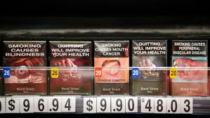
Above is and example of plain packaging in Australia.
Although, many people say that tobacco can help lower the use of illegal drugs. It just causes another addiction that is misconstrued as a healthier habit. But, the other forms of tobacco have just about the same effects if not worse. Nicotine is what causes the addiction. Studies have been proven that trying to stop nicotine or tobacco usage is as hard as trying to stop opioid use. Nicotine release idrialine causing your body to have a sensational feeling. This adrenal rush cause dopamine to be released into your body. Dopamine is a neurotransmitter that contributes to feelings of, pleasure, satisfaction and reward; however, if too much is released it can have bad effects on the body. Soon, your body will become dependent on nicotine to give you that sensation. When you do not get the nicotine, your body will not feel good, and symptoms of with drawls will become present. With drawl symptoms come in many forms, some of the most common forms are depression, mood swings, restless, cold sweets, nausea, and slowed heart rate. With drawls last for about two to three weeks, the first week is when most people tend to relapse because the symptoms are the strongest then. Smoking also no only effects your health, but the people around you. The people around you have the same ditorating health effects that you are receiving by smoking, even if you do not smoke around them the smoke in your clothes can still damage their body. 90% of lung cancer cases are caused by smoking. When you smoke a cigarette there are about 4,000 other chemicals that are not supposed to be in the human body. There are many other health affects that can occur, like bad breath, rotting teeth, cancer, hair loss, loss of vision, etc.
Below is a picture of how the brain process the nicotine when you smoke.
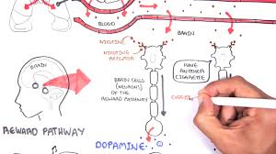
Lastly, Indonesia should adopt more strict smoking restrictions. This would benefit they society. They health and death rate would go down. This would allow more kids to live longer and have better health. Also, less second hand smoking would occur.

In conclusion,

Work Cited
https://abcnews.go.com/Health/age-children-smoking-indonesia/story?id=14464140
https://www.cdc.gov/tobacco/data_statistics/by_topic/policy/regulation/
https://www.cdc.gov/tobacco/data_statistics/by_topic/policy/regulation/
http://theconversation.com/disneyland-for-big-tobacco-how-indonesias-lax-smoking-laws-are-helping-next-generation-to-get-hooked-97489
http://www.health.gov.au/internet/main/publishing.nsf/content/71E0A33CC534C8D2CA257D10001B78FD/$File/Reviewed-Enforcement-Policy-May-2018.pdf
https://abcnews.go.com/Health/age-children-smoking-indonesia/story?id=14464140
Hoffman, Jan. “E-Cigarettes Are Effective at Helping Smokers Quit, a Study Says.” The New York Times, 25 Jan. 2019, www.nytimes.com/2019/01/30/health/ecigarettes-nicotine-smoking-quit.html?rref=collection/timestopic/Smoking and Tobacco&action=click&contentCollection=timestopics®ion=stream&module=stream_unit&version=latest&contentPlacement=3&pgtype=collection.
( I am not done with my sources)

